Assignment 1: ICEPOT-Banking_Fund-Transfer_Test Cases
Instructions:
- Fund transfer test cases within the same bank
- [STRICT] Functional only — positive and negative
- [MANDATORY] Include TC ID, Priority, Description, Precondition, Steps, Expected/Actual Result, Test Data
- [CRITICAL] Mix of P0, P1, P2
- [MANDATORY] Exactly 10 test cases
- Then switch persona and review, adding comments

Context:
Banking app's fund transfer feature — transfers between two accounts within the same bank.

Example:
TC-ID: TC001 Priority: P1
Description: Verify fund transfer between two same-bank accounts succeeds
Precondition: App running; both accounts have sufficient balance
Steps: 1) Log in 2) Enter destination account 3) Enter amount & submit
Expected Result: Transfer succeeds; both balances update
Test Data: Acc 1: 445556 · Acc 2: 434343 · Amount: $1000

Persona:
- Generate: Banking Domain QA Engineer, expert in functional testing
- Review: Team Lead, reviewing the test cases

Output Format:
10 test cases in a table, followed by a short review summary and Team Lead comments.

Tone:
[STRICT] Professional tone in review comments and summary.
Output: From Open AI
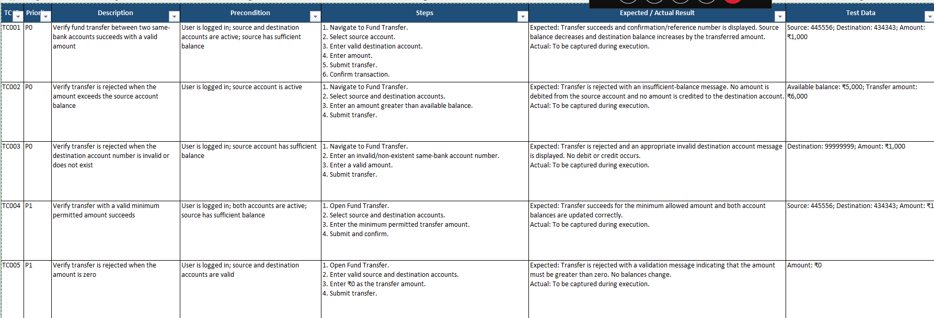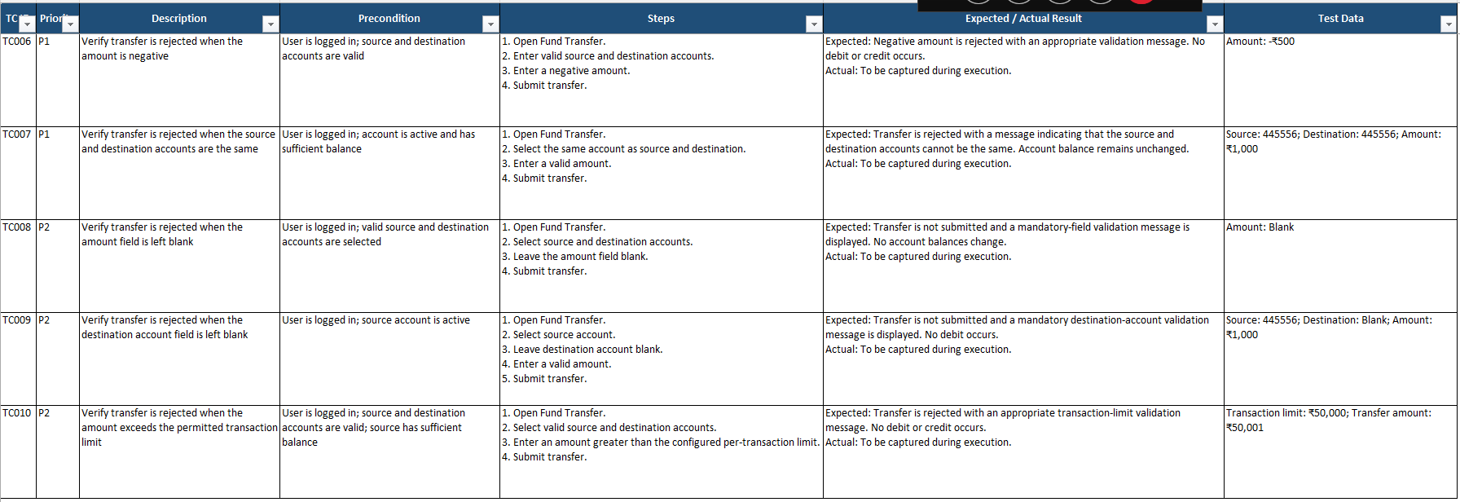
Output from Claude:

Assignment 2: ICEPOT-Bug Reporting Dashboard-HTML Output
Instructions:
- Generate a Bug Reporting Dashboard as a single self-contained HTML file
- [STRICT] No external dependencies — all CSS/JS inline
- [MANDATORY] Totals: open/closed, severity (P0–P3), bugs by module & assignee
- [CRITICAL] One chart (bar/pie) for severity distribution
- [MANDATORY] Sortable/filterable bug table (ID, Title, Severity, Status, Assignee, Module)
- Responsive layout for desktop and tablet
Context:
QA team tracks bugs across multiple projects and sprints in a spreadsheet today; needs a single-page visual dashboard to review status and trends without a backend.

Example:
Bug ID: BUG-1042 Severity: P1
Title: Login button unresponsive on Safari
Status: Open Assignee: Priya Module: Auth

Persona:
- Generate: Frontend/QA Tooling Engineer skilled in building HTML/CSS/JS dashboards
- Review: QA Lead, reviewing usability and accuracy of the dashboard

Output Format:
Single .html file — summary on top, chart in the middle, bug table at the bottom.

Tone:
[STRICT] Clean, professional dashboard UI copy; no jargon in labels.
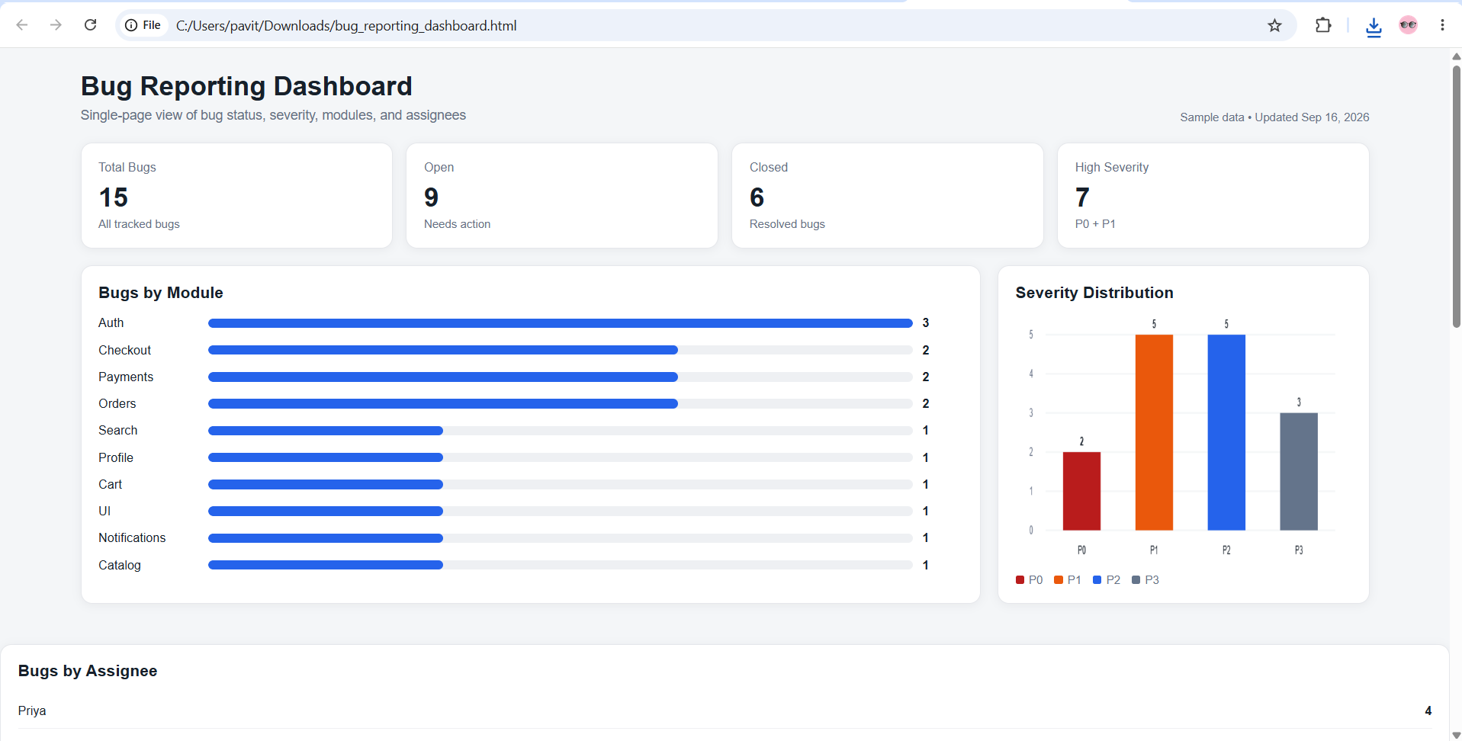

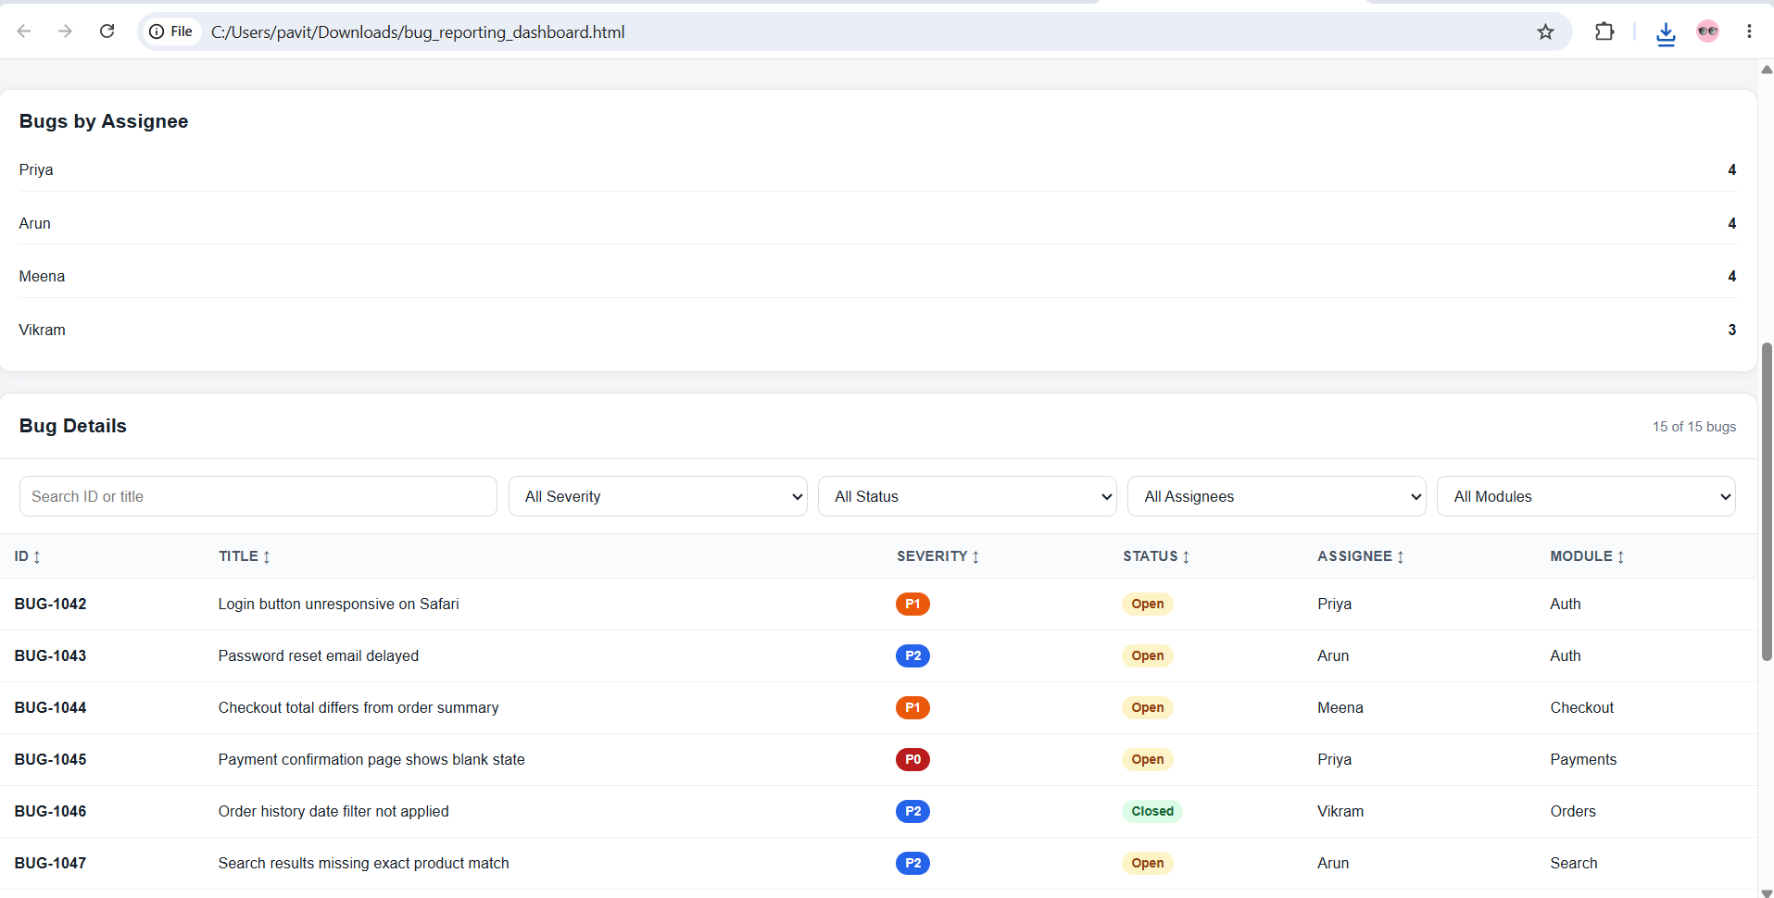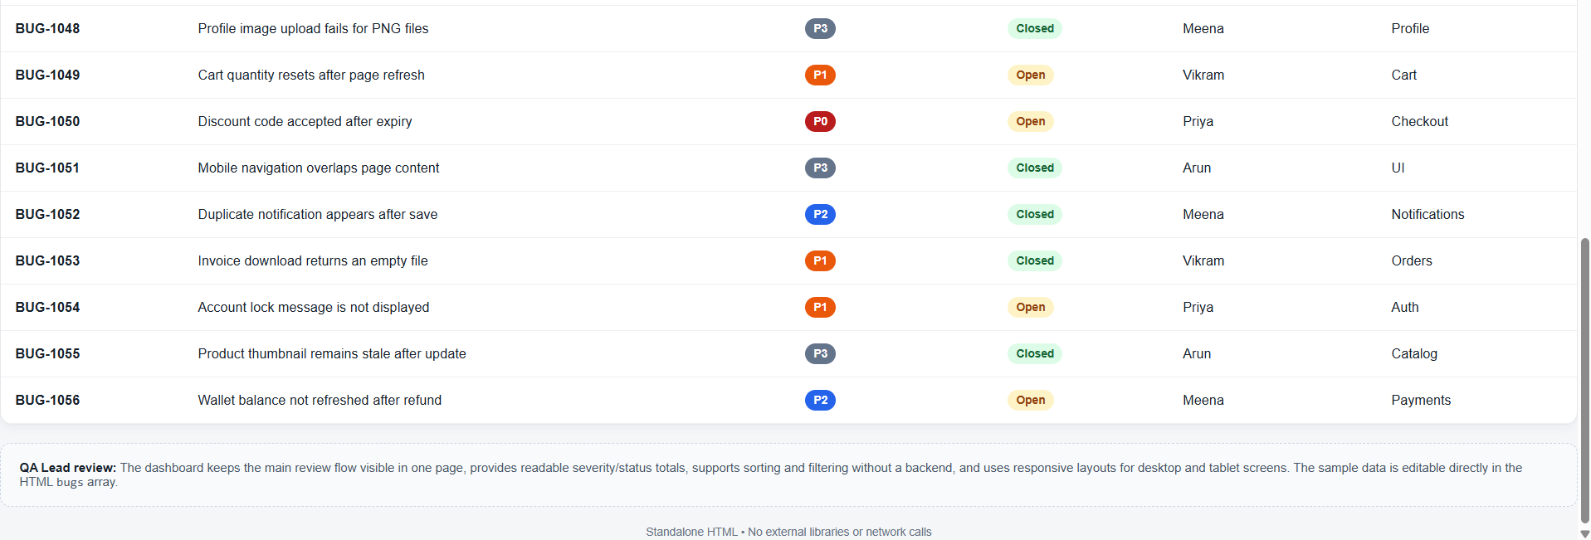

Assignment 3 : ICEPOT-Selenium-Java-Script-Generation
Instructions:
- Generate a Selenium Java test script using TestNG for the login functionality
- [STRICT] Use Page Object Model design pattern
- [MANDATORY] @BeforeMethod/@AfterMethod for WebDriver setup/teardown
- [MANDATORY] Explicit waits (WebDriverWait) — no Thread.sleep
- [CRITICAL] Cover both positive and negative test scenarios
- TestNG assertions with clear failure messages

Context:
E-commerce web app login page — username/password fields, "Remember me" checkbox, "Forgot password" link; runs on Chrome, must support headless execution via TestNG XML.

Example:
@Test: testValidLogin()
Enter valid username & password, click Login
Assert redirect to /dashboard URL
Assert welcome banner text contains logged-in user's name

Persona:
- Generate: SDET skilled in Selenium WebDriver, Java, TestNG, and Page Object Model
- Review: Automation Lead, reviewing code quality and framework standards

Output Format:
Complete Java classes — Page Object class + TestNG test class, ready to paste into an IDE, plus a TestNG XML snippet for execution.

Tone:
[STRICT] Clean, production-quality code with meaningful comments

Output: LoginPage.java
package pages;

import java.time.Duration;

import org.openqa.selenium.By;
import org.openqa.selenium.WebDriver;
import org.openqa.selenium.WebElement;
import org.openqa.selenium.support.ui.ExpectedConditions;
import org.openqa.selenium.support.ui.WebDriverWait;

/**
* Page Object representing the e-commerce Login page.
*/
public class LoginPage {

private final WebDriver driver;
private final WebDriverWait wait;

// Page locators
private final By usernameField = By.id("username");
private final By passwordField = By.id("password");
private final By rememberMeCheckbox = By.id("rememberMe");
private final By loginButton = By.cssSelector("button[type='submit']");
private final By forgotPasswordLink = By.linkText("Forgot password");
private final By loginErrorMessage = By.cssSelector(".login-error");
private final By welcomeBanner = By.cssSelector(".welcome-banner");

public LoginPage(WebDriver driver) {
this.driver = driver;
this.wait = new WebDriverWait(driver, Duration.ofSeconds(10));
}

public LoginPage enterUsername(String username) {
WebElement element = wait.until(
ExpectedConditions.visibilityOfElementLocated(usernameField));

element.clear();
element.sendKeys(username);

return this;
}

public LoginPage enterPassword(String password) {
WebElement element = wait.until(
ExpectedConditions.visibilityOfElementLocated(passwordField));

element.clear();
element.sendKeys(password);

return this;
}

public LoginPage selectRememberMe() {
WebElement checkbox = wait.until(
ExpectedConditions.elementToBeClickable(rememberMeCheckbox));

if (!checkbox.isSelected()) {
checkbox.click();
}

return this;
}

public void clickLogin() {
wait.until(ExpectedConditions.elementToBeClickable(loginButton)).click();
}

public void clickForgotPassword() {
wait.until(ExpectedConditions.elementToBeClickable(forgotPasswordLink)).click();
}

public String getLoginErrorMessage() {
return wait.until(
ExpectedConditions.visibilityOfElementLocated(loginErrorMessage))
.getText();
}

public String getWelcomeBannerText() {
return wait.until(
ExpectedConditions.visibilityOfElementLocated(welcomeBanner))
.getText();
}

/**
* Performs a complete login operation.
*/
public void login(String username, String password) {
enterUsername(username);
enterPassword(password);
clickLogin();
}
}

2. LoginTest.java

package tests;

import java.time.Duration;

import org.openqa.selenium.WebDriver;
import org.openqa.selenium.chrome.ChromeDriver;
import org.openqa.selenium.chrome.ChromeOptions;
import org.openqa.selenium.support.ui.ExpectedConditions;
import org.openqa.selenium.support.ui.WebDriverWait;
import org.testng.Assert;
import org.testng.annotations.AfterMethod;
import org.testng.annotations.BeforeMethod;
import org.testng.annotations.Test;

import pages.LoginPage;

/**
* TestNG test class for e-commerce login functionality.
*/
public class LoginTest {

private WebDriver driver;
private WebDriverWait wait;
private LoginPage loginPage;

private static final String BASE_URL =
"https://your-ecommerce-app.example.com/login";

private static final String VALID_USERNAME =
"valid.user@example.com";

private static final String VALID_PASSWORD =
"ValidPassword123";

@BeforeMethod
public void setUp() {

ChromeOptions options = new ChromeOptions();

// Enables headless execution when -Dheadless=true is supplied.
if (Boolean.parseBoolean(System.getProperty("headless", "false"))) {
options.addArguments("--headless=new");
}

options.addArguments("--window-size=1920,1080");
options.addArguments("--disable-gpu");
options.addArguments("--no-sandbox");
options.addArguments("--disable-dev-shm-usage");

driver = new ChromeDriver(options);

wait = new WebDriverWait(driver, Duration.ofSeconds(10));

driver.manage().timeouts().implicitlyWait(Duration.ZERO);
driver.manage().timeouts().pageLoadTimeout(Duration.ofSeconds(30));

loginPage = new LoginPage(driver);

driver.get(BASE_URL);

// Explicit wait confirms that the login page is ready.
wait.until(ExpectedConditions.urlContains("/login"));
}

/**
* Positive scenario:
* Valid username and password should successfully log in.
*/
@Test(description = "Verify login with valid username and password")
public void testValidLogin() {

loginPage.login(VALID_USERNAME, VALID_PASSWORD);

// Verify redirect after successful login.
boolean dashboardDisplayed = wait.until(
ExpectedConditions.urlContains("/dashboard"));

Assert.assertTrue(
dashboardDisplayed,
"Login failed: expected redirect to '/dashboard', but current URL was: "
+ driver.getCurrentUrl());

// Verify welcome message.
String welcomeMessage = loginPage.getWelcomeBannerText();

Assert.assertTrue(
welcomeMessage.contains("Welcome"),
"Login succeeded but welcome banner did not contain expected text. "
+ "Actual banner: " + welcomeMessage);
}

/**
* Negative scenario:
* Invalid password should prevent login.
*/
@Test(description = "Verify login fails with invalid password")
public void testInvalidPassword() {

loginPage.enterUsername(VALID_USERNAME);
loginPage.enterPassword("InvalidPassword123");
loginPage.clickLogin();

String errorMessage = loginPage.getLoginErrorMessage();

Assert.assertTrue(
errorMessage.toLowerCase().contains("invalid")
|| errorMessage.toLowerCase().contains("incorrect"),
"Expected an invalid-credentials error message, but received: "
+ errorMessage);

Assert.assertFalse(
driver.getCurrentUrl().contains("/dashboard"),
"User was incorrectly redirected to dashboard with invalid credentials.");
}

/**
* Negative scenario:
* Empty username and password should prevent login.
*/
@Test(description = "Verify login validation for empty credentials")
public void testEmptyCredentials() {

loginPage.clickLogin();

String errorMessage = loginPage.getLoginErrorMessage();

Assert.assertTrue(
errorMessage.toLowerCase().contains("required")
|| errorMessage.toLowerCase().contains("enter"),
"Expected required-field validation message, but received: "
+ errorMessage);

Assert.assertFalse(
driver.getCurrentUrl().contains("/dashboard"),
"User was redirected to dashboard despite empty credentials.");
}

/**
* Positive scenario:
* Remember Me checkbox should be selectable.
*/
@Test(description = "Verify Remember Me checkbox can be selected")
public void testRememberMe() {

loginPage.selectRememberMe();

// Locate the checkbox through the Page Object indirectly by
// completing the login flow. The test validates successful login
// with the Remember Me option enabled.
loginPage.enterUsername(VALID_USERNAME);
loginPage.enterPassword(VALID_PASSWORD);
loginPage.clickLogin();

boolean dashboardDisplayed = wait.until(
ExpectedConditions.urlContains("/dashboard"));

Assert.assertTrue(
dashboardDisplayed,
"Login failed when Remember Me was selected.");
}

/**
* Functional check:
* Forgot Password link should navigate to the password recovery page.
*/
@Test(description = "Verify Forgot Password link navigation")
public void testForgotPasswordLink() {

loginPage.clickForgotPassword();

boolean recoveryPageDisplayed = wait.until(
ExpectedConditions.urlContains("/forgot-password"));

Assert.assertTrue(
recoveryPageDisplayed,
"Forgot Password link did not navigate to the expected "
+ "'/forgot-password' page. Current URL: "
+ driver.getCurrentUrl());
}

@AfterMethod(alwaysRun = true)
public void tearDown() {

if (driver != null) {
driver.quit();
}
}
}

3. testng.xml
<?xml version="1.0" encoding="UTF-8"?>

<!DOCTYPE suite SYSTEM
"https://testng.org/testng-1.0.dtd">

<suite name="Login Test Suite" parallel="false">

<parameter name="headless" value="true"/>

<test name="E-Commerce Login Tests">

<classes>
<class name="tests.LoginTest"/>
</classes>

</test>

</suite>

Automation Lead review
- POM: Page-specific locators and actions are isolated in LoginPage.
- Wait strategy: Uses WebDriverWait/ExpectedConditions; no Thread.sleep().
- Test isolation: Every test gets a fresh browser through @BeforeMethod and closes it through @AfterMethod(alwaysRun = true).
- Coverage: Includes valid login, invalid password, empty credentials, Remember Me, and Forgot Password.
- Assertions: Each assertion has a meaningful failure message.
- Headless: Chrome can execute without a visible browser through TestNG XML.
- Maintainability: URL, credentials, and locators are centralized and can be moved to configuration files/environment variables for CI.
- Production recommendation: Replace the placeholder URL, locators, and credentials with the application's actual values; credentials should preferably come from environment variables or a secrets store rather than source code.

Assignment 4:

Instructions:
- Generate a Selenium Java script to verify login on a Salesforce app. Include setup/teardown, explicit waits.”
- [MANDATORY] @BeforeMethod/@AfterMethod for WebDriver setup/teardown
- [MANDATORY] Explicit waits (WebDriverWait) — no Thread.sleep
- [CRITICAL] Cover both positive and negative test scenarios
- BDD framework assertions with clear failure messages

Context:
Salesforce web app login page — username/password fields, "Remember me" checkbox, "Forgot password" link; runs on Chrome, must support headless execution via TestNG XML.

Example:
@Test: testValidLogin()
Enter valid username & password, click Login
Assert redirect to /dashboard URL
Assert welcome banner text contains logged-in user's name

Persona:
- Generate: SDET skilled in Selenium WebDriver, Java, Cucumber BDD, and Page Object Model
- Review: Automation Lead, reviewing code quality and framework standards

Output Format:
Complete Java classes — Page Object class + BDD test class, ready to paste into an IDE, plus a BDD XML snippet for execution.

Tone:
[STRICT] Clean, production-quality code with meaningful comments.

Output:

Assignment 5: "You are a QA engineer. Write a bug report for a checkout crash on Chrome after clicking 'Place Order' with an empty cart — severity, repro steps, expected vs actual."
Instructions:
- Generate a bug report for a checkout crash on chrome after clicking 'place order' with an empty cart-.”
- [MANDATORY] severity, repro steps, expected vs actual
- [CRITICAL] Cover both positive and negative test scenarios
-

Context:
Write a bug report for a checkout crash on Chrome after clicking 'Place Order' with an empty cart.

Example:
Bug ID: BUG-1042 Severity: P1
Title: Login button unresponsive on Safari
Status: Open Assignee: Priya Module: Auth

Persona:
- Generate: Frontend/QA Tooling Engineer skilled in building HTML/CSS/JS dashboards
- Review: QA Lead, reviewing usability and accuracy of the dashboard

Output Format:
Single .html file — summary on top, chart in the middle, bug table at the bottom.

Tone:
[STRICT] Clean, professional dashboard UI copy; no jargon in labels

Output:

